**Assignment Title: Serverless Event Logging System using AWS Lambda and PostgreSQL**

**Objective**

Design and implement a serverless backend function using **AWS Lambda** that logs user activity data into a **PostgreSQL** database hosted on **Amazon RDS**. This assignment emphasizes hands-on experience with cloud services, API integration, database design, and secure credentials management.

**Learning Outcomes**

By completing this assignment, you will:

* Understand and apply the **Infrastructure-as-Code** and **Serverless** principles.
* Set up and manage a **PostgreSQL** database on AWS RDS.
* Create and deploy **AWS Lambda** functions using the AWS Console or CLI.
* Use **Secrets Manager** to store and retrieve sensitive information securely.
* Integrate Lambda with **Amazon API Gateway** to expose the function over HTTPS.
* Use **IAM roles and policies** for secure Lambda execution.
* Perform **SQL operations** from a cloud function using environment variables and secrets.
* Understand how serverless functions interact with persistent databases.

Create database using AWS console:

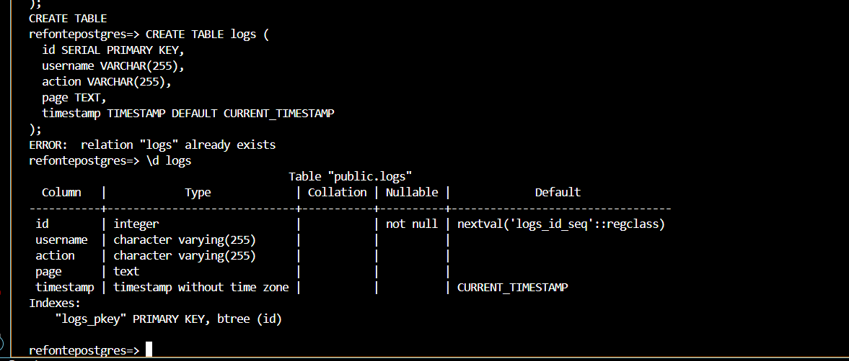

Lambda function:

Environment variable:

Configure Lambda API gateway:

Deliverable:

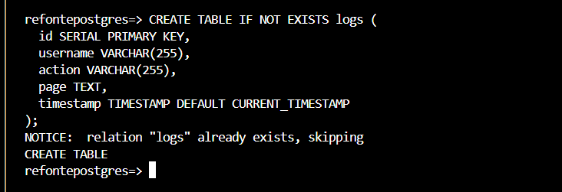

Table created:

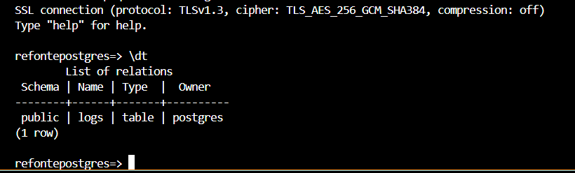

**Lambda code:**

Test using curl:

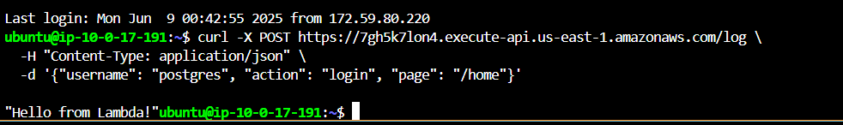

Test using postman:

